Patch Management

Prepared by: Abhinav Malhotra
Pulkit

INDEX
I Business Case
1.0 Introduction/Background
2.0 Project Objective
3.0 Problems/Opportunity
4.0 Critical Assumption and Constraints
5.0 Analysis of Solution and Recommendations
6.0 Preliminary Project Requirements
7.0 Budget Estimate and Financial Analysis
8.0 Schedule Estimate
II Project Plan
1.0 Scope
2.0 Project Phases
3.0 WBC
4.0 Gantt Chart
5.0 Budget
6.0 Time Management
III Risk Management
1.0 Potential Risk
2.0 Risk Table
3.0 Risk Diagram
4.0 Risk Mitigation
IV Quality Control
1.0 Project Quality
2.0 Project Launch Quality
3.0 Problem Log Tracking
V Change Control
1.0 Change Control
2.0 Change Control Radius Server
3. 0 Change Request Form
VI Training and Communication
VII Network Design
VIII Wireless Network Design

I Business Case

1.0 Introduction/Background
The Client, RBC is going to setup a new building with 10 new labs for the next semester. They have requested the implementation of a Patch Management solution and Wi-Fi Infrastructure for their new building. And they want it to be implemented with the highest industry standards. So, they made a request for the entire project to be based on the National Institute of Standards and Technology (NIST) Special Publication (SP) 800-40 – Guide to Enterprise Patch Management Technologies.

2.0 Project Objective

- Patch Management Solution Based on the NIST Standards
- Vulnerability Management Life Cycle
- Secure Network Design and Setup
- Wireless Infrastructure Deployment with proper security standards
Project's main objective is patch management solution for all the devices in the RBC college. To meet this objective, we need to implement the Vulnerability Management Life Cycle. And Secondary Objective is to implement the Wireless Infrastructure. A bonus objective is to implement a secure and robust network design which will directly benefit the entire project.

3.0 Problems/Opportunity Statement

- Lack of Technical Expertise
- Hard to Patch Everything
- Schedule for Patches
- Wi-Fi Signal Strength
- Networking Complexing
The client, RBC college being an educational institution, they lack expertise of big enterprises. So, it needs to be kept in mind to give proper documentation and training. It needs to be kept in mind it is not possible to apply the patch as soon as it is released, or software/hardware cannot be patched due to some reason. To effectively manage this, we need to draft a policy to patch the most important and critical vulnerability first. To avoid any disruption of service for the client.
Wi-Fi signal strength is important for Wi-Fi infrastructure to work. There are some barriers which interfere with the wireless signal strength. Thus, resulting in the loss of connectivity and affecting the efficiency of the wireless network.
Adding new devices to the college will bring a complete set of complexity to it. This can result in loose ends, less secure design, loops, Wastage of Bandwidth etc. If there is problem later, it will hard track it down and fix it

4.0 Critical Assumption and Constraints
- Multi-Platform Support
- Technical Staff Already Present
- Integration to OLD IT infrastructure
- Room for Growth
It needs to be kept in mind about the share number of devices and with the number of Different OS running on them. The solution should be flexible, which will consider the number of services and hardware OS in the project. And give us expansion possibilities.
The client already has technical staff present, Proper Training and Demo for the entire project need to be arranged for them. Their roles need to decide in the project which not only make them familiar with the functionality of the project but can also help reduce the cost of hiring new workforce just for the project
Assumption there is already IT infrastructure present such as Active Directory, Certification Authority, Domain Name System etc. Integrating the new infrastructure with it. So, bearing that in mind we need to take measures to integrate the old infrastructure with the new one. Saving some cost which comes from doing everything from beginning.

By keeping growth and flexibility in mind, we have done this project. So later it is possible for easy expansion or to make changes, for example leaving enough subnet space for the room for growth on the network. Increase in number of endpoints for wireless infrastructure. By adding an extra wireless controller or more wireless access points.

5.0 Analysis of Solution and Recommendations
- Using a centralized patch management system can help reduce the burden of patch management and the scheduling of the maintenance. And help fulfill many requirements for NIST Frame for Patch Management.
- Network Vulnerability Scanner will help identify known vulnerabilities on the network
- A Wireless Controller for the Wi-Fi Infrastructure
- For Networking Device Enterprise networking switch routers and firewalls

For Patch Management
These are some good solutions available in the market:
Atera is a patch management solution offered as a Software as a Service (SAAS). This tool is designed to cover any business IT needs and it supports all the platforms. Atera offers many features for patch management, custom workflows for scheduling etc.
Pros:
- Comprehensive Reporting for patch management
- Multi-Platform Support
- Full Patch management like Priority Patching, Patch testing, Automatic Patch deployment
- Centralized Management for all the devices.
- Cost Effective and support unlimited devices\
- AI Integration
Cons:
- IT supplies many other features which might not be suitable for business needs.
- Need Training
- Being Provided as software as a service can have its limitations

Ninja One enables fully automation of patch management process. It is also a multi-platform tool. It also has windows third party application patching. It is also cloud-based. It helps make IT administration easier. It is a part of IT system monitoring and management tool.
Pros:
- Multi-Platform Support
- Automatic Patching can be easily scheduled
- A centralized platform which can be easily accessed
- A simple but a powerful tool with extensive documentation
- Patch Activity logs, Reports, Reboot Management etc.
- Compliance Monitoring

Cons:
- Lack of Support for Mobile Devices
- It is not an independent patch management solution but a part of Entire package of MSP. Some features might not be used.
ManageEngine Patch Manager Plus is a complete patch management solution. It can be deployed in the clouds or on premises. It supports a wide range of endpoints and over 600 third-party updates and over 350 applications.
Pros:
- It has features such as testing & Approving Patches, decline patches and patches for third-party applications.
- It supplies features for automatic deployment
- Ensures compliance
- Real-time audits and reporting
- Options for Integrations with other Solutions
- Three Versions: Free, Professional, Enterprise
Cons:
- This is a complex application which takes time to get used to it and use it to its full capabilities.
NinjaOne. (2023). NinjaOne pricing: Only pay for what you need. NinjaOne. https://www.ninjaone.com/pricing/
ManageEngine, communications@manageengine.com. (n.d.). Features | ManageEngine Patch Manager Plus. https://www.manageengine.com/patch-management/features.html
Top 11 BEST Patch Management Software Tools [UPDATED 2023 LIST]. (2023, September 25). Software Testing Help. https://www.softwaretestinghelp.com/patch-management-software/
Keary, T., & Keary, T. (2023). The best patch Management Software & tools for 2023. Comparitech. https://www.comparitech.com/net-admin/best-patch-management-software-tools/
Sheldon, R. (2022). 12 best patch management software and tools for 2023. Enterprise Desktop. https://www.techtarget.com/searchenterprisedesktop/tip/12-best-patch-management-software-and-tools

Wireless Controllers

Cisco Catalyst 9800-L
The Cisco Catalyst 9800-L is a fixed wireless controller with seamless software updates for small and midsize enterprises. It is a critical business-ready controller with support for WI-FI 6 and comes with a dashboard for easier management.

Features
- Up to 250 Accesspoint's Support
- Can support up to. 5000 maximum clients
- Up to 5GPS throughput
- Comes with many defaults' security features
- Supports high availability
Cisco Catalyst 9800-L Wireless Controller Data Sheet. (2023, March 1). Cisco. https://www.cisco.com/c/en/us/products/collateral/wireless/catalyst-9800-series-wireless-controllers/datasheet-c78-742434.html

Wing NX 7500 Integrated Services Platform from Extreme Switching
Advanced Performance and One Point of Control for your Entire Wireless LAN
(WLAN). It is a feature reach wireless controller with security, AAA, reliability build-in. It also comes with advanced features which allow it to configure the router for wireless traffic depending on the access point. It also has a single dashboard for centralized management.
Features
- Fast and Easy setting it up
- Hierarchical Management with a single dashboard for centralized management
- Integrated Network Security Services
- End to End Support Services for this product.
WiNG NX 7500. (n.d.). Extreme Networks. https://www.extremenetworks.com/products/wlan-controllers/wing-controllers/wing-nx-7500
Gartner, Inc. (n.d.). My Account | Gartner Peer Insights. https://www.gartner.com/reviews/market/enterprise-wired-wireless-lan-access-infrastructure/compare/product/cisco-wireless-controllers-vs-extreme-switches=

Networking Devices
Hewlett Packard Enterprise is renowned for its emphasis on unified networks and for being at the top of the enterprise networking solutions market. Numerous features that reduce networking complexity are supported by it, including automated policy enforcement. A platform exists that additionally facilitates enhanced programmability using Python scripts.

Pros
- Effective Automated Security
- Internet of Things (IoT) device onboarding procedures and centralized management are examples of network operations.
- For increased visibility, networking visibility measures include tracking all infrastructure data and forwarding it to a single source.

Cons
- HP products have some integration problems with some software and services.
Networking products and services. (n.d.). HPE. https://www.hpe.com/us/en/networking.html

Cisco Systems Digital Network Architecture, a software-delivered method for automated systems, is provided by Cisco Systems. Furthermore, it offers centralized management. Another system that makes use of AI/Ml to manage network devices exists.

Features
- Capability to scale:
- Visibility
- Ease of Managing the network
Cons
- Expensive License

Network Vulnerability Scanner
Over 47,000 flaws can be found with the vulnerability scanning tool Nessus. Since it has the lowest possibility rate of all vulnerability scanners, a lot of large enterprises utilize it. With more than 130,000 plugins, this scanner publishes a new plugin within 24 hours of finding a new vulnerability.
Pros
- Simple and easy to learn so it can save some precious time that might be used in training
- Easy to configure
Cons
- Expensive for the enterprise support
NESsus Vulnerability Scanner: Network Security Solution. (n.d.). Tenable®. https://www.tenable.com/products/nessus

OpenVAS is an open-source vulnerability scanner which is a part of green borne vulnerability management. Its uses green borne community feed to run over 50,000 vulnerability tests and has support for over 26,000 CVE
Pros
- Open-Source. Tool
- Completely Free but an enterprise support plan is provided which gives support in case of any problems
- Integrates all the latest CVE and frameworks into its products
Cons
- Complex to Configure
Keary, T., & Keary, T. (2022, April 27). Nessus vs OpenVAS. Comparitech. https://www.comparitech.com/net-admin/nessus-vs-openvas/
OpenVAS - Open Vulnerability Assessment Scanner. (n.d.). https://openvas.org/

6.0 Preliminary Project Requirements

The requirement of this project is:
- Policy for Patch management, Vulnerability Management, Wireless and Network which will describe all the necessary requirements.
- Accounting for all the Assests such as devices, servers, data etc.
- Assign Each asset to a Maintenance Group (according to the importance)
- Preparing, Deploying, Verifying and Monitoring for the Patch
- Vulnerability Scanner Server for detection of vulnerability
- Subscribing to Threat Data Intelligence Feeds
- Survey Site for Heat Map
- Radius Server with EAP protocol for the best wireless security with WPA 3 Enterprise
- Security system for protecting the network
- External Audit for Security Standards and Patch Management Solution
7.0 Budget Estimate and Financial Analysis

The budget for this project is estimated to be 30-35k. I recommend moving forward with this project as it is critical from a security perspective.
- Assumption and Estimation
- Estimate Patch Management tools cost will be around $1200-$1500 a year
- Cost for hardware's needed
- Cost for technical Expertise to supervise the project
- Cost for Training for the staff
- Implementation Cost
- Wireless Implementation Cost
- External Auditing
- On Site Visit

8.0 Schedule Estimate
The Project will take at least 1 and half Month to complete, All the required tasks are given below.

Tasks | Days
1.0 Project Planning and Consulting | 4
2.0 Patch Management 4.0 Network Design and Implementation | 5
3.0 Vulnerability Management | 4
4.0 Patch Management | 4
5.0 Wireless Implementation | 5
6.1 Training for all the Required Staff  6.2 Documentation for the process and procedure | 7
7.0 Testing the Solution for any gaps in a test environment | 3
8.0 Policy for Patch Management, Vulnerability, Wireless and Network  8.1 Documented Design for Wireless  8.2 Documented Design for Network | 2
9.0 Present the Entire Project  9.1 External Audit | 2
10.0 Put it in Production Mode and Prepare for Project Closure | 2

II Project Plan

1.0 Scope

- Secure & Robust Network.
- A Segmented Network
- Firewall for Security
- All security Features enables on Switches (STP, BPDU, MAC Filtering)
- DMZ zone for the public facing services and hardware

- Vulnerability Mangement
- Network Vulnerability Scanner
- Threat Data Feed for Latest News on the Vulnerability Discovered
- Vulnerability Management Life Cycle
- Maintenance for the Vulnerability scanner
- Patch Management
- Assest Accounting.
- Divided Assest in a Maintenance Groups based on Importance
- Patch Management Life Cycle
- Automated Patching for Endpoints using a third-party solution

- Wireless Availability
- Site Heat Map
- Wireless Controller for Centralized Mangement
- Integrated With Client Active Directory
- RADIUS Server with Extensible Authentication Protocol with WPA 3 for security.
- Risk Management and Mitigation
- Documentation &Policy for each Solution
- External Audit for compliance and project quality

The Client, RBC college has new building with a respectable number of devices so First thing is to design a network and implement it. So that we can proceed with other steps of the Project

Network Solution will see a properly segmented network depending on the departments. All the networking devices will be password protected. The entire network will be built with redundancies. So that there is no single point of failure. All security features on the networking devices will be enabled such as STP, BPDU guard, Mac Filtering etc. All the traffic will be encrypted to prevent man in middle attack. Security system at the border of network which will filter unwanted traffic and prevent malicious traffic from coming in. Also helps filter traffic that is going out. Adding all the devices to the existing Active Directory and DNS server. A DMZ zone will be created for servers which are public facing such as college websites etc. Subnet space will be left for growth in the network.

Vulnerability Management will make it possible for proper patch management. As it will give us the Insite on the Vulnerability. Whether it is Critical or Not etc.? Does it need to be Patched or not? So First a Network Vulnerability Scanner will be installed on a server which will regular
scan the network and all the host present for the vulnerability and mark them with CVE. Threat Data feeds are vulnerability discovered by security researcher. So, subscribing for this type of feed will increase the posture for the security of the client. Vulnerability Mangement life cycle will go hand in hand with the patch management life cycle. Vulnerability Management life – Discover, check for CVE number (critical or not), Check if Patch is Available – then move to the Patch Management Life Cycle. Regular Update for the Vulnerability Scanner will provide the latest results as vulnerability scanner comes with database of. Known vulnerability.
Patch Management implementation is the focus of the project. This implementation will consist of patch management software which will help carry most of the load of endpoints patching and updating their OS and Services running on them. As for the Servers and Network Devices we need to follow the NIST framework – Patch Management life cycle – Discover, Test and Deploy. All the Important Devices will be divided in management groups depending on the workloads they are running. And then scheduling the maintains plan depending on the network activity as per information gathered from the client.

Wireless Infrastructure will consist of a wireless controller and Access points. Wireless Controller will make it possible for central management of the wireless infrastructure. We will also implement a RADIUS server with EAP (Extensible Authentication Protocol) and WAP3 enterprise for the best possible security. Guest Wi-Fi will also be provided, and it will be separated from the internal wireless.

2.0 Project Phases

Phase | Tasks | Days
1 | 1.0 Project Planning and Consulting | 4
2 | 2.0 Network Design and Implementation | 5
 | 3.0 Vulnerability Management | 4
4 | 4.0 Patch Management | 4
5 | 5.0 Wireless Implementation | 5
6 | 6.1 Training for all the Required Staff  6.2 Documentation for the process and procedure | 7
7 | 7.0 Testing the Solution for any gaps in a test environment | 3
8 | 8.0 Policy for Patch Management, Vulnerability, Wireless and Network  8.1 Documented Design for Wireless  8.2 Documented Design for Network | 2
9 | 9.0 Present the Entire Project  9.1 External Audit | 2
10 | 10.0 Put it in Production Mode and Prepare for Project Closure | 2

3.0 WBS
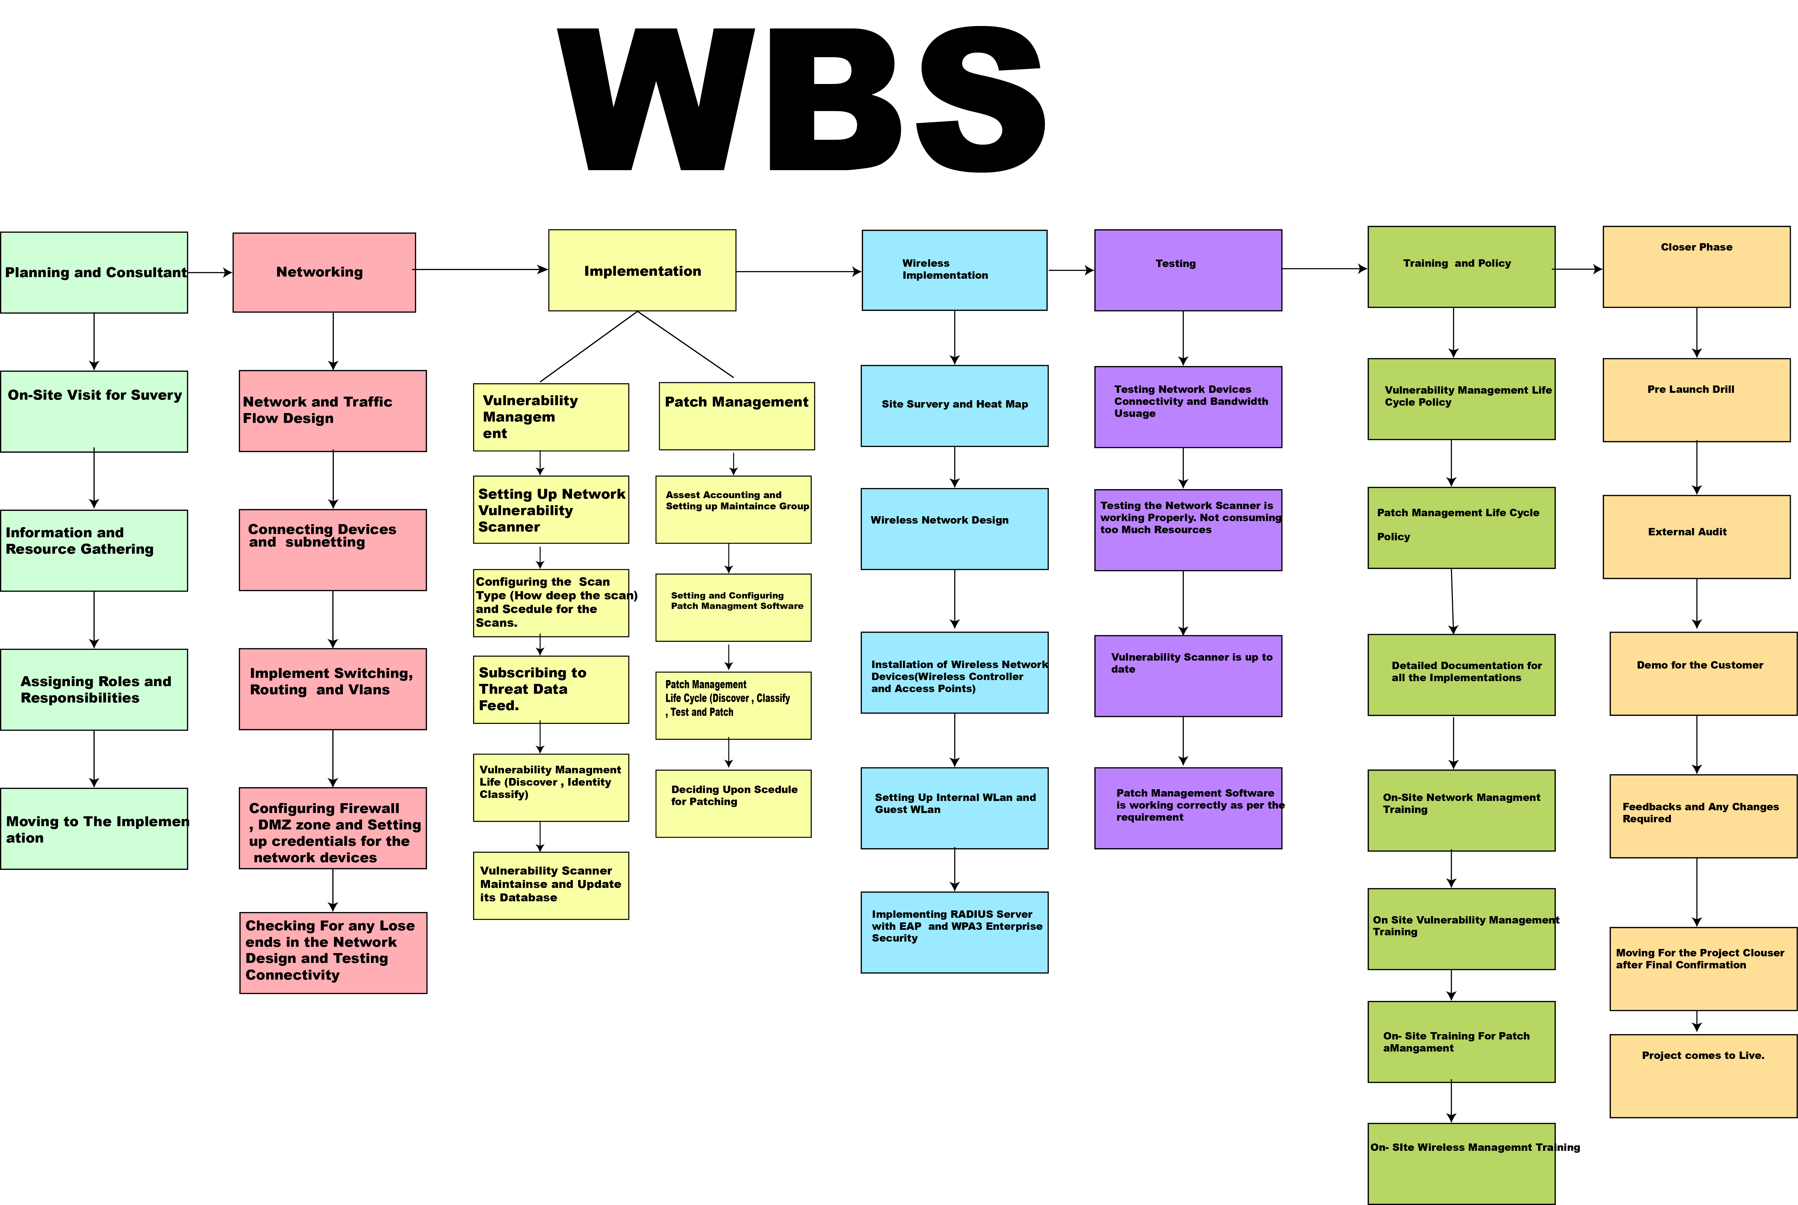

4.0 Gantt Chart

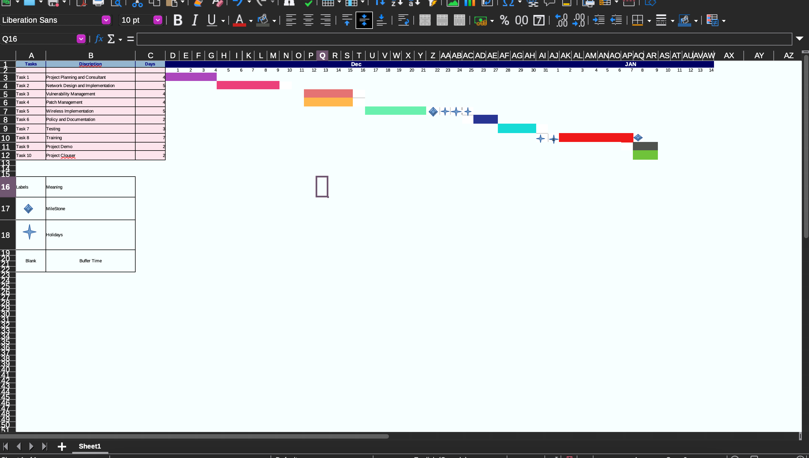

5.0 Budget
The budget for this project is estimated to be 30-35k. I recommend moving forward with this project as it is critical from a security perspective.
Assumption and Estimation
- Estimate Patch Management tools cost will be around $1200-$1500 a year
- Vulnerability and Threat Data feed Cost
- Cost for hardware's needed
- Cost for technical Expertise to supervise the project
- Cost for Training for the staff
- Implementation Cost
- Wireless Implementation Cost
- External Auditing
- On Site Visit

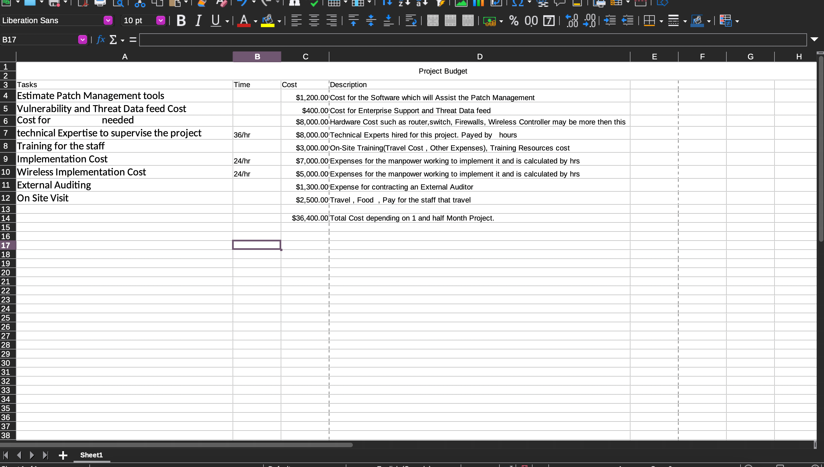

6.0 Time Management

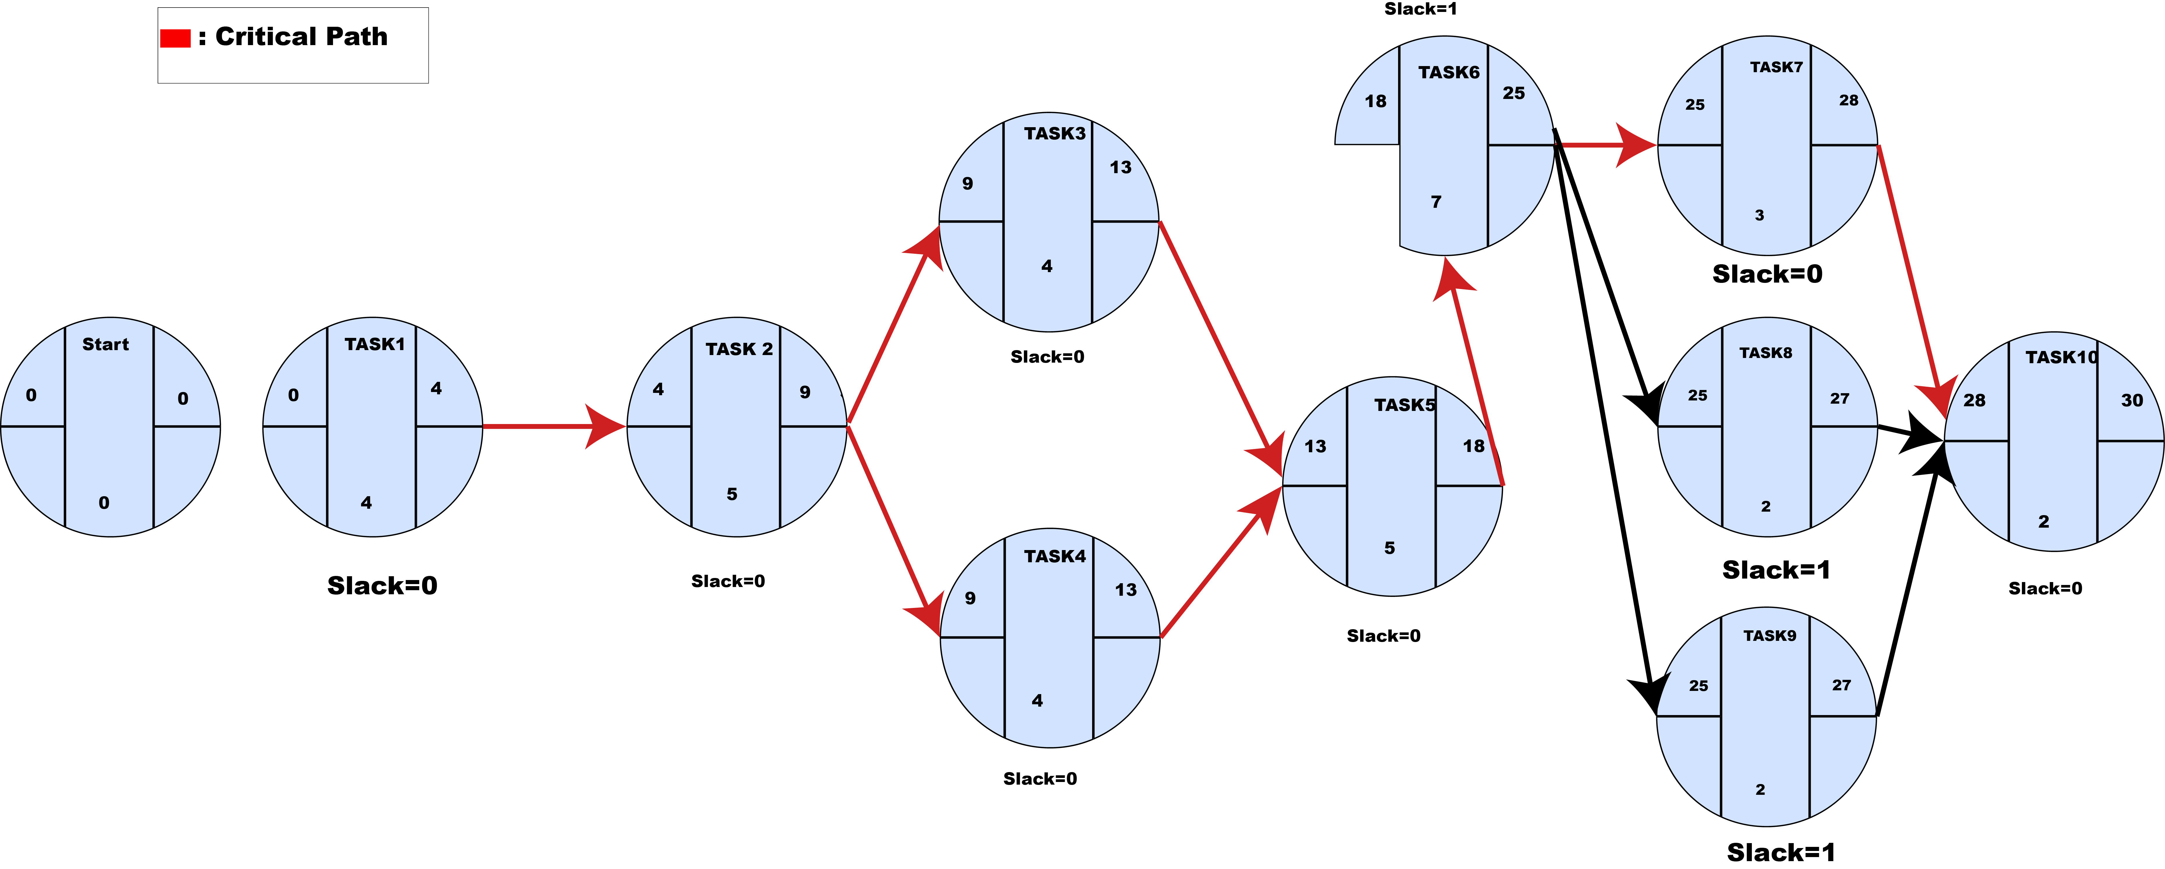

III RISK Management

1. Potential Risks
- Gap in Network Design
- Failure to keep the vulnerability scanner up to date
- Assests which cannot be patched
- Lack of technical expertise
- Delays on Site survey for heatmap

Gap in Network Design such as not considering network security will leave the client network vulnerable. If the Design is more focused on availability it will create a risk of making the network open beyond what is required. Gap in Network design might also lead to connectivity and speed issues resulting in delays for the entire project.
Failure to keep the vulnerability scanner up to date results in scanner database not being updated with signatures of recent vulnerability discovered. Will affect the quality of the project. because if a critical vulnerability is not discovered how, it will be possible to patch it.
Some Assests running services might no longer be supported by the vendor. So, it cannot be patched or the Assest cannot be updated as the software which are required does not. support higher version. These will affect the product of the project and might result in the project delay if the assets were updated accidentally.
Lack of Staff will result in the project being delayed or failure if the client cannot use the project's functions to its full capacity.
Delays or Gaps in Site Survey for heat map will result in some areas of the building without any signal or less signal strength. Any delays from extreme weather or any events in the client site will affect the project moving forward.

2.0 Risk Table

Risk Event | Probability | Impact | Risk Index
GAP in Network Design | 4 | 5 | 20
Vulnerability Scanner Maintains | 2 | 5 | 10
Unpatchable devices, services | 5 | 3 | 15
Staff | 4 | 3 | 12
Delays or Gaps in Heat MAP | 2 | 2 | 4

3.0 Risk Diagram
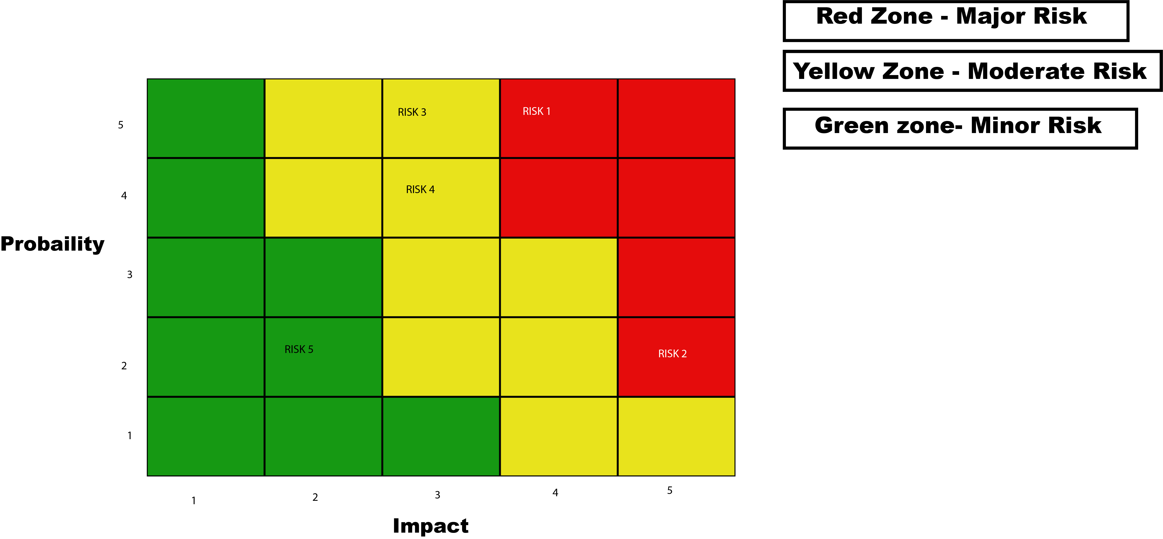

4.0 Risk Mitigation

We can eliminate Gaps in the network design by following defense in depth strategy by consulting a security analyst and testing the network at the earlier stage of project. So, a buffer time has been included in the network design timeline to test the entire network.

We will mitigate the risk that comes from not updating the scanner by creating a separate policy for the vulnerability scanner. Also, a technical staff member will be assigned for this task and a standby staff member will provide backup in case the main staff cannot perform his/her job.

For Unpatchable assets we can do is either remove them if they are not required by the client or isolate them from another network. It is risk acceptance and all we can do is try to reduce the losses.

Lack of technical staff issues will be mitigated by proper training of all the present staff with proper documentation of all the project working. If required inexperienced staff will be hired.

Any delays in the Site survey for heat map will be mitigated by consulting the client to schedule site survey. To not interrupt any of the client's work and backup schedule in case of any unseen circumstances.

IV Quality Control

1.0 Project Quality
- Test Plan
- Compliance
- Monitoring Network
- Wireless Speed and Connectivity
- Client Feedback and email support
Test Plan

Project will be tested with highest security standards. Testing plans have already been already included during the project planning. After the implementation we will move to the testing phase. Where Each implementation will be tested as per the standards. So that we will meet the goals and requirements of the project plan.

2.0 Project Launch Quality

Compliance
A third-party compliance activity will be carried out. To test the controls and security procedures, Patch Management Implementation complies with NIST Framework as per the client requirements. So, in case any requirement is missing we can implement it without any delay by following change management procedures.

Monitoring Network
Network will be Monitored to check all the devices are working as per the configuration. And a device is not using excess bandwidth. Any interruptions in the network will be monitored. So that there is no problem after the project is handled to the client.

Wireless Speed and Connectivity
Wireless Speed and Connectivity will be monitored by its staff in different areas of the site. To check the quality of wireless network.

Client Feedback and email support
Client feedback will be set up after the project has been launched whether they are satisfied with the project and support email is setup if there is still problem after the launch project.

Tester | Activity | Expectation
IT staff, Network Engineer | Network Testing | All Network devices are connected, and network is working properly
Security analyst, Network Engineer | Secuiry Configuration of Devices | All security Settings are configured such as STP and Proper Segmentation is followed
IT STAFF | Scanner False Positive | Test that scanner is not sending too much false positive
IT STAFF | Review Assest Management | All the Assests are accounted and Put in Proper Maintains Group
IT Staff | Patch Management Life Cycle | Proper Patch Management Life Cycle is followed
Third Party | Compliance | All the Standards are meet and are Compliant with NIST standards
Wireless Engineer, IT Staff | Access Points | All the Access Points are working and there is no rogue access point
IT STAFF | Wireless Signal Strength | Testing all the signal Strength of  The entire site.

3.0 Problem Log tracking

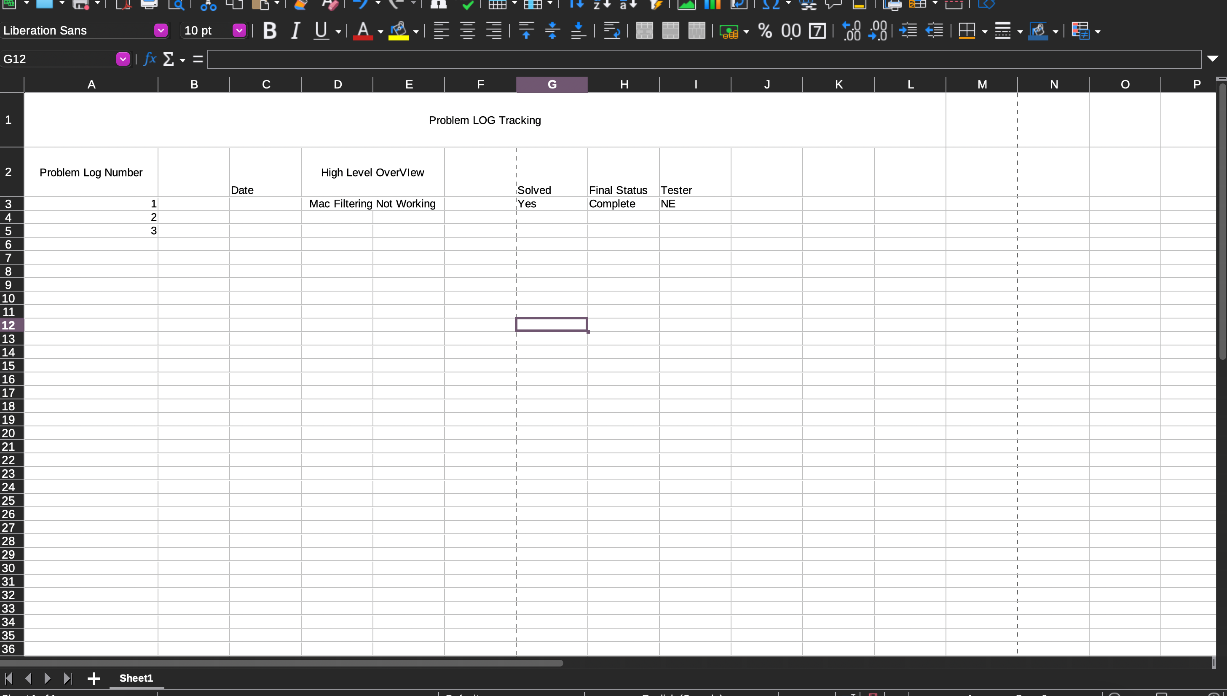

V. Change Control

1.0 Change Control
- Request Submitted via change request template
- Radius Server for Wireless Authentication using EAP with WPA3-Enterprise

Change Request
The request for the change shall be submitted via email using the change request template. Project Manager will look at schedule, Cost which comes with the change request and then respond after all the calculation. The project committee consisting of Project Manager, Security Analysts, Wireless Engineer, Director will approve or reject the request.

IF the Committe has approved the change. All the members and the client shall be informed via email.

2.0 Change Control Radius Server with EAP and WPA3-Enterprise
- A Radius Server shall be set up for authentication over the wireless network. The Radius server will first be integrated with the Active directory of the client. Then we will move forward to the next step
- We will Integrate the Certificate Authority with the RADIUS Server for encrypted exchange of credentials

- Extensible Authentication Protocol is the standard for remote Authentication, and it can be used with the Wireless Network. EAP will provide a means for the users to Authenticate securely. It needs to be configured with WPA3- Enterprise for the authentication over the radius server.

3.0 Change Request Form

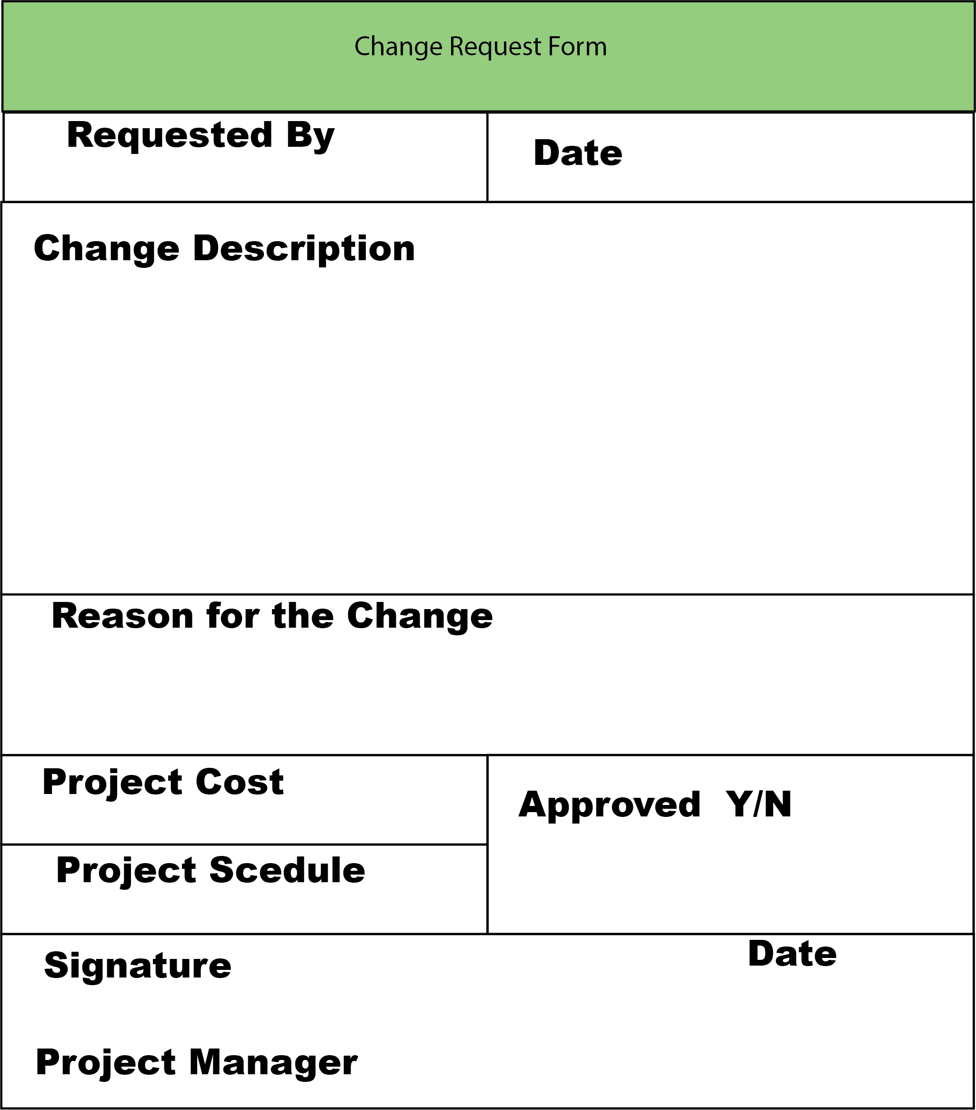

VI Training and Communication

1.0 Communications
- Phone calls for tasks Completions and Normal working
- Meetings and Emails for the Stakeholder
- Urgent Phone Calls and Emergency Meeting
- Credentials handling
- Networking Design and Wireless Design
All communication will be done via internal email systems and phone calls. All the important persons such as security analysts, network engineer and wireless engineer will be informed about their respective supervision tasks by IT-Staff to keep them informed by phone calls.
All the stakeholders such director, client and project manager will be informed via email about
the tasks completed. When milestones are reached a meeting will be held to direct the next part of the project.

If there is any problem, a phone call will be made to the project manager immediately. And an urgent meeting will be held in the next 24 hours. And emails will be sent to all the influential figures about the meeting.

All the networking devices credentials will be held securely by 3 people network engineer, Wireless Engineer, and Security Analyst. After the project's finishing, the credentials will be passed on to the client via end-to-end encrypted email, and credentials must be reset by the client just in case.

This design should only be known to the internal staff working on the project. Later passed on to the client IT-Staff via encrypted email with an expiration date of email of 7 days.

2.0 Training
- On-site Training
- Drill of the Project
- Face-to-Face Event

On-site training will be held for the client and its IT Staff for showing the entire working of the project and Copies of the documentation will be distributed among the staff. On-site training will also contain video lectures and presentations.

After the On-line training Session. A drill will be conducted by IT staff to see how they manage the project's entire working.

After the Drill, a face-to-face session will be conducted. To get to know the challenges they face during the drill and whether more training is required.

VII Network Design
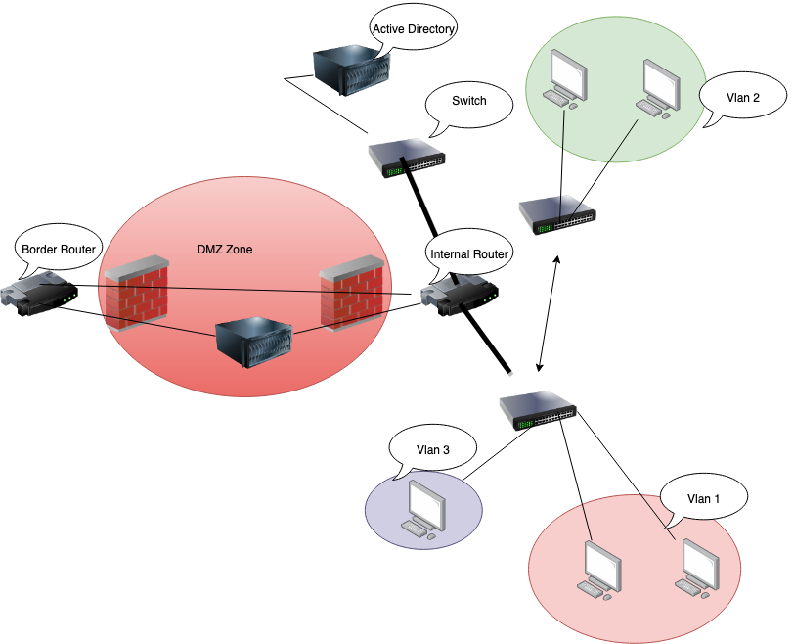

VII Wireless Network Design


